学号：1711143

姓名：王忠汉

**Answer 1:**

N=0:200;

L=[16 32 64];

S1=N/L(1).*power((1-1/L(1)),N-1);

S2=N/L(2).*power((1-1/L(2)),N-1);

S3=N/L(3).*power((1-1/L(3)),N-1);

plot(N,S1,N,S2,N,S3);

xlabel('待识别电子标签数量');

ylabel('吞吐量');

legend('L=16','L=32','L=64');

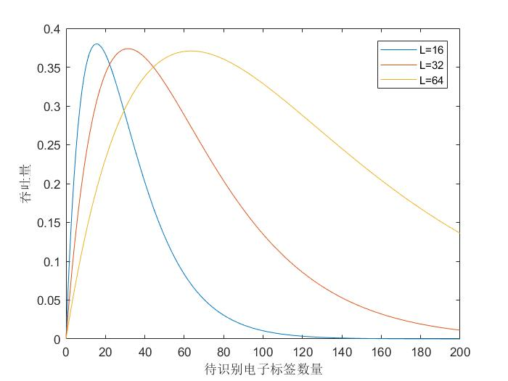

**Answer 2:**

figure

N=0:100;

S=N./(N+log2(factorial(N)));

plot(N,S);

xlabel('待识别电子标签数量');

ylabel('吞吐量');

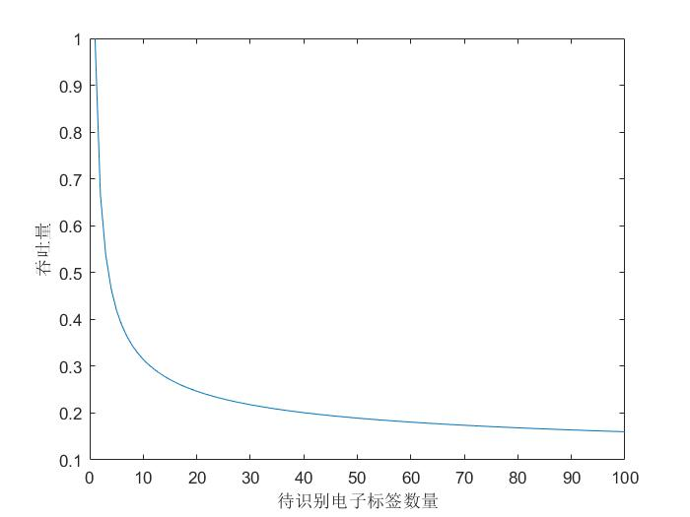

**Answer 3(1):**

figure

subplot(2,2,1);

z=0:0.1:6*pi;

x=cos(z);y=sin(z);

plot3(x,y,z);

title('三维曲线');

subplot(2,2,2);

plot3(x,y,z),view(0,90);

title('俯视图');

subplot(2,2,3);

plot3(x,y,z),view(90,0);

title('左侧视图');

subplot(2,2,4);

plot3(x,y,z),view(0,0);

title('前视图');

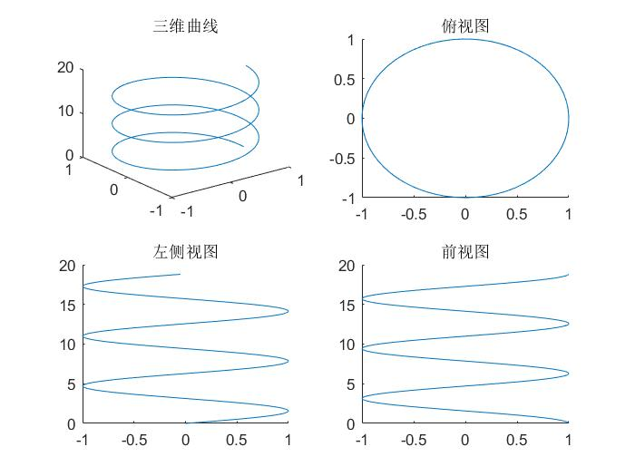

**Answer 3(2):**

figure

subplot(2,2,1);

x=-4:0.2:4;

y=x;

[X,Y]=meshgrid(x,y);

Z=X.^2/9+Y.^2/9;

mesh(X,Y,Z);

title('椭圆抛物面网线图')

subplot(2,2,2);

surf(X,Y,Z);

title('椭圆抛物面网面图')

subplot(2,2,3);

x=-7.5:0.5:7.5;

y=x;

[X,Y]=meshgrid(x,y);

R=sqrt(X.^2+Y.^2)+eps;

Z=sin(R)./R;

mesh(X,Y,Z);

title('阔边帽面网线图')

subplot(2,2,4);

surf(X,Y,Z);

title('阔边帽面网面图')

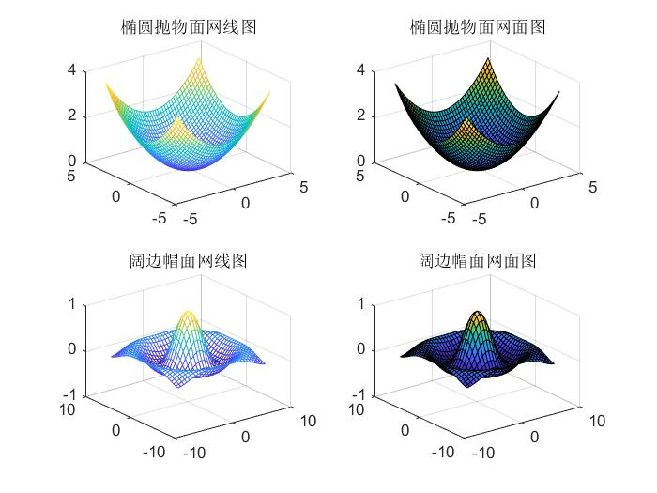

**Answer 3-practice:**

figure

x=-2:0.1:2;

y=x;

[x,y]=meshgrid(x,y);

Z=x.^2.*exp(-(x.^2+y.^2));

surf(x,y,Z);

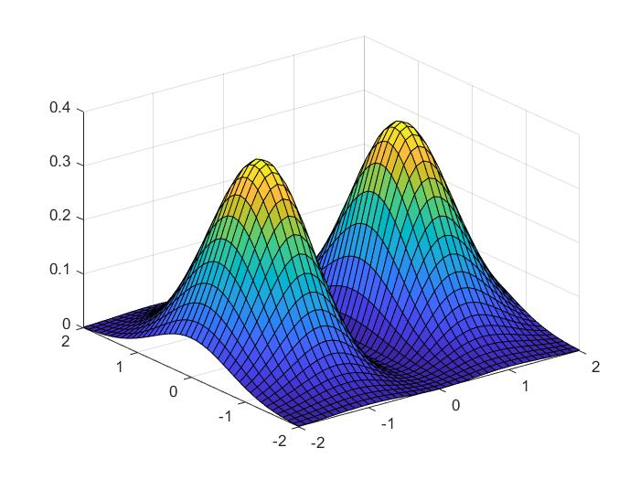

**Answer 4:**

x=imread('tu.jpg');

figure

subplot(1,2,1);

imshow(x);

subplot(1,2,2);

y=255-x;

imshow(y);

imwrite(y,'reverse.jpg');

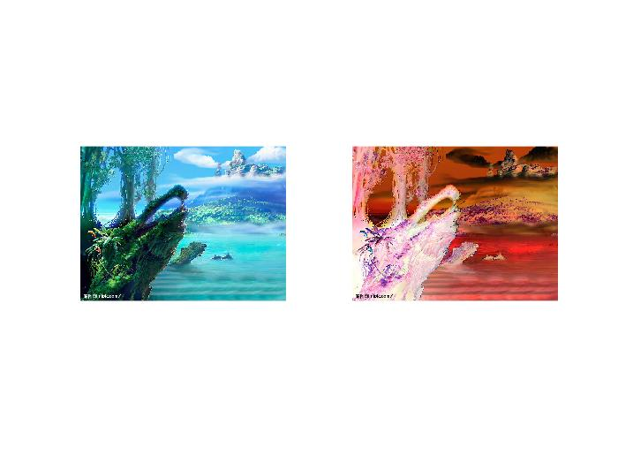

**Answer 5:**

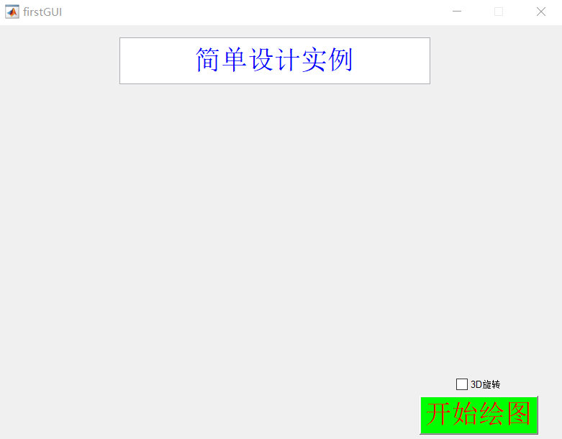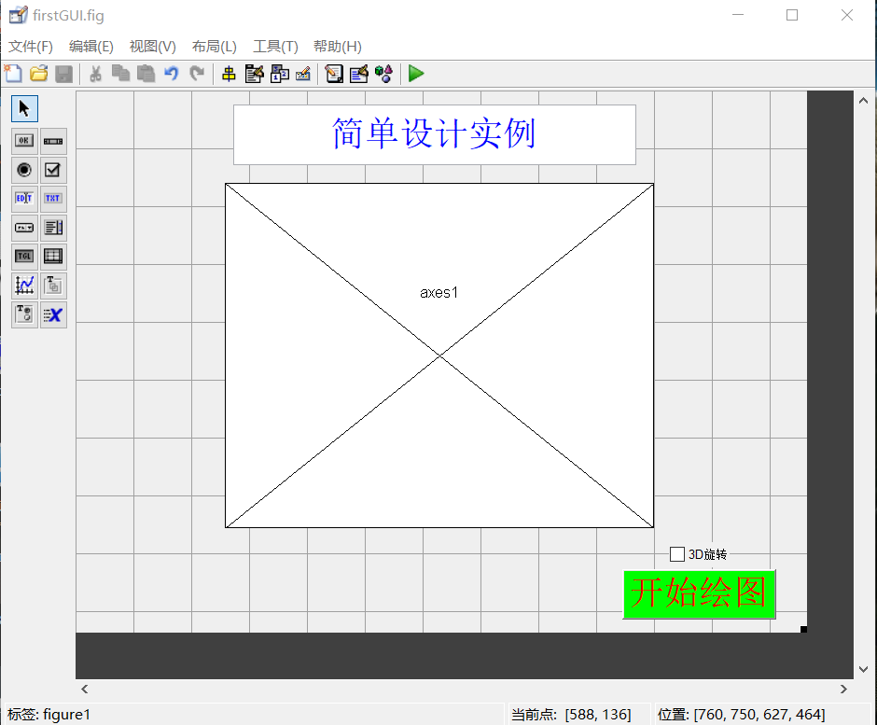

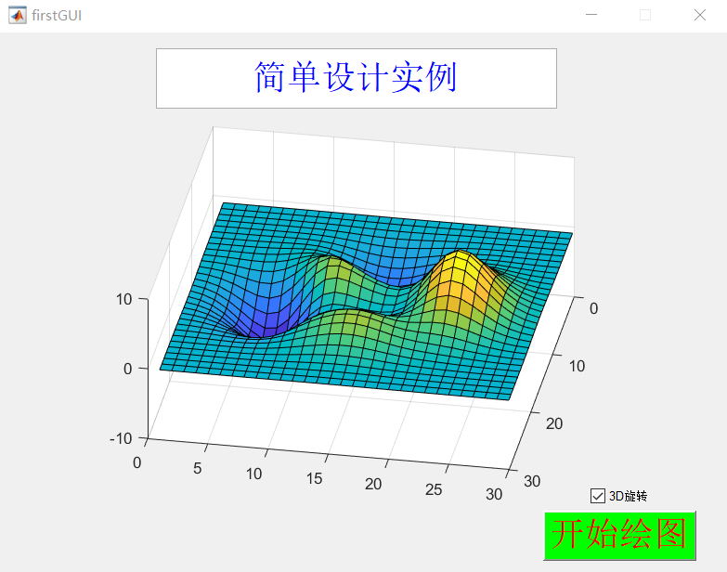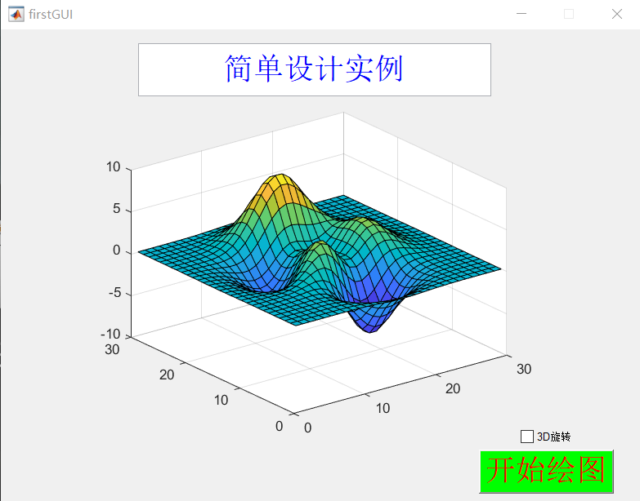

function varargout = firstGUI(varargin)

% FIRSTGUI MATLAB code for firstGUI.fig

% FIRSTGUI, by itself, creates a new FIRSTGUI or raises the existing

% singleton*.

%

% H = FIRSTGUI returns the handle to a new FIRSTGUI or the handle to

% the existing singleton*.

%

% FIRSTGUI('CALLBACK',hObject,eventData,handles,...) calls the local

% function named CALLBACK in FIRSTGUI.M with the given input arguments.

%

% FIRSTGUI('Property','Value',...) creates a new FIRSTGUI or raises the

% existing singleton*. Starting from the left, property value pairs are

% applied to the GUI before firstGUI_OpeningFcn gets called. An

% unrecognized property name or invalid value makes property application

% stop. All inputs are passed to firstGUI_OpeningFcn via varargin.

%

% *See GUI Options on GUIDE's Tools menu. Choose "GUI allows only one

% instance to run (singleton)".

%

% See also: GUIDE, GUIDATA, GUIHANDLES

% Edit the above text to modify the response to help firstGUI

% Last Modified by GUIDE v2.5 16-Mar-2019 10:02:20

% Begin initialization code - DO NOT EDIT

gui_Singleton = 1;

gui_State = struct('gui_Name', mfilename, ...

'gui_Singleton', gui_Singleton, ...

'gui_OpeningFcn', @firstGUI_OpeningFcn, ...

'gui_OutputFcn', @firstGUI_OutputFcn, ...

'gui_LayoutFcn', [] , ...

'gui_Callback', []);

if nargin && ischar(varargin{1})

gui_State.gui_Callback = str2func(varargin{1});

end

if nargout

[varargout{1:nargout}] = gui_mainfcn(gui_State, varargin{:});

else

gui_mainfcn(gui_State, varargin{:});

end

% End initialization code - DO NOT EDIT

% --- Executes just before firstGUI is made visible.

function firstGUI_OpeningFcn(hObject, eventdata, handles, varargin)

% This function has no output args, see OutputFcn.

% hObject handle to figure

% eventdata reserved - to be defined in a future version of MATLAB

% handles structure with handles and user data (see GUIDATA)

% varargin command line arguments to firstGUI (see VARARGIN)

% Choose default command line output for firstGUI

handles.output = hObject;

% Update handles structure

guidata(hObject, handles);

% UIWAIT makes firstGUI wait for user response (see UIRESUME)

% uiwait(handles.figure1);

% --- Outputs from this function are returned to the command line.

function varargout = firstGUI_OutputFcn(hObject, eventdata, handles)

% varargout cell array for returning output args (see VARARGOUT);

% hObject handle to figure

% eventdata reserved - to be defined in a future version of MATLAB

% handles structure with handles and user data (see GUIDATA)

% Get default command line output from handles structure

varargout{1} = handles.output;

function edit1_Callback(hObject, eventdata, handles)

% hObject handle to edit1 (see GCBO)

% eventdata reserved - to be defined in a future version of MATLAB

% handles structure with handles and user data (see GUIDATA)

% Hints: get(hObject,'String') returns contents of edit1 as text

% str2double(get(hObject,'String')) returns contents of edit1 as a double

% --- Executes during object creation, after setting all properties.

function edit1_CreateFcn(hObject, eventdata, handles)

% hObject handle to edit1 (see GCBO)

% eventdata reserved - to be defined in a future version of MATLAB

% handles empty - handles not created until after all CreateFcns called

% Hint: edit controls usually have a white background on Windows.

% See ISPC and COMPUTER.

if ispc && isequal(get(hObject,'BackgroundColor'), get(0,'defaultUicontrolBackgroundColor'))

set(hObject,'BackgroundColor','white');

end